**Who’s On The Bus Exercise – 20 Min**

**OBJECTIVE:** Identify with whom we can work to move this action forward.

**HOW:**

* **Who’s driving the bus? (2 min)**

Tell them the objective of this activity and point out that so far there is only one person on this bus.

Ask: “*Who do you want to have driving this bus?”*

Point out that we need leaders but if we all take turns driving the bus – share the leadership and the work – we will be able to drive further down road.

* **Who in the community can ride the bus? (5 min)**

Ask: “*Who do we want to make sure is on the bus?”*  Draw a few stick figures riding in the bus.

Start with the community: Ask if there are groups of people in the community, not already involved, that would be important to include. Draw stick figures on the bus, and write names above them.

Ask: “*Is this bus accessible?”* “*Is there anything we need to do to make sure that the community people we have listed can participate?*” (e.g. meeting space, childcare or language support, time   
of meetings)

* **Potential allies on the bus (10 min)**

Explain that allies or partners are people or organizations that share some common interests in reaching our goal. In some cases, they will have power and influence to make change. Ask: “*Who can we work with to achieve our goal?”* When they name groups or individuals, draw more stick figures and write their name above.

You might include potential funders in your list.

On a flipchart, draw two columns, the first titled POTENTIAL ALLIES, the second titled INTERESTS. Ask: “*Who on this bus are we not sure will work with us?”*

Pick 3 – 4, and write them in the column POTENTIAL ALLIES. Ask: “*Why would it be in their interest to be involved?” “How might they benefit?” Under INTERESTS, write ideas.*

* 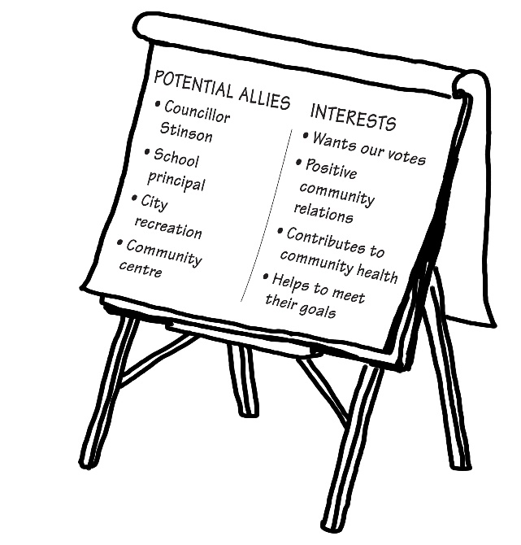**Summarize** **(3 min)**

Fill in the Action Plan Road Map,

under *Potential Allies*.

